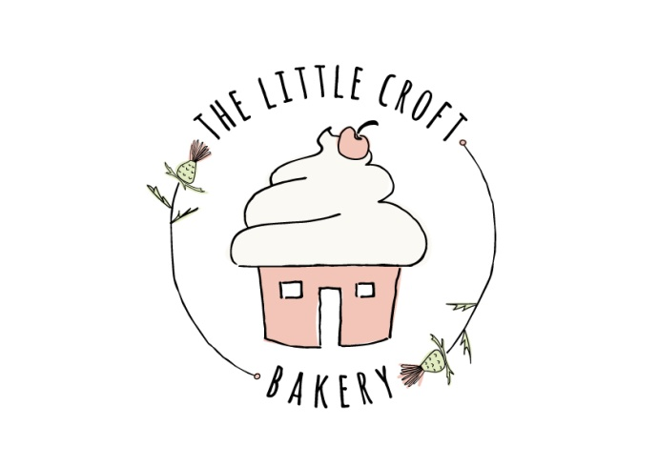

## TERMS & CONDITIONS

**Eilidh Orrell, The Little Croft Bakery, The Croft, Greenleonachs, Culbokie, IV78JD, 07845503763**

Please ensure you read through the following before agreeing to your order. Once your initial payment is paid your booking is confirmed and bound by these Terms and Conditions.

​**PAYMENT POLICY**

Weddings and Event Dessert Tables

When placing an order for dessert tables an £80 non-refundable initial payment is required to confirm the date. No date is confirmed until this has been received. The final balance is due to be paid no later than one month before the date of the event. If the final amount is not paid, a reminder will be sent and if no reply it will be presumed that the order has been cancelled and the booking closed. The initial payment will not be returned.

Payment

Payment to be made by bank transfer.

**FOOD ALLERGY DISCLAIMER**

The Little Croft Bakery is not an allergen-free kitchen and cannot guarantee that any product will be completely free of any ingredient. Due to the seriousness of food allergies I ask that you speak to me about any food allergies that you or your party have. I reserve the right to decline an order due to allergies.

The following ingredients may be present in any of our products:

* CEREALS CONTAINING GLUTEN
* EGGS
* MILK
* SOYA
* PEANUTS AND TREE NUTS
* SULPHER DIOXIDE (dried fruit)

Please also note that some food colourings may have an adverse effect on the behaviour of children.

​**COLLECTION/** **DELIVERY POLICY**

Wedding and Event Dessert Tables

Dessert tables to be set up at the venue by The Little Croft Bakery incur an Admin/ Set up fee of £50 within a 15 mile radius of Culbokie. For any event out with this area an additional £1 will be charged per mile.

Where applicable, Little Croft Bakery stands and equipment will be collected the day after your event at a time previously agreed and should be ready for collection in one place at the agreed time.

**HIRE OF STANDS/ EQUIPMENT**

If choosing to hire The Little Croft Bakery cake stands and equipment a fee of £75 will be charged. This includes equipment hire and a collection fee (within 15 miles of Culbokie) for the day after the event. For any event out with this area an additional £1 will be charged per mile. Any loss or damages must be paid for and will be invoiced after the event.

Collection time will be arranged prior to the day of the event and items should be together in one place at the time agreed for collection.

**TRAVELLING WITH YOUR CAKE**

The cake should be placed in the passenger foot well or empty boot of the car on a non-slip surface. DO NOT place the cake on a seat in the car, seats are slanted and can damage the cake. Please turn on air conditioning. Extra care should be taken when driving as some elements may be delicate. The Little Croft Bakery cannot take any responsibility for damage to cakes once collected.

​**STORAGE**

All cakes should be placed on a flat surface and stored in a cool room in the box provided. They should be kept out of direct sunlight and away from heat sources (e.g. radiators). In warm weather it is advised to keep your buttercream cake in the fridge and remove 30 minutes before serving. To enjoy at their best, cakes should be consumed within 3 days.

**CHANGES TO YOUR ORDER**

I understand that circumstances can change and I will do my best to accommodate any changes to your order. Due to other bookings, date changes may not be able to be accommodated. Should your new date be unavailable, the non-refundable initial payment will be retained however I will return any other payment made less any equipment/ ingredients that have been bought specifically for your order.

Changes to design may incur additional costs, please discuss these with me as early as possible.

Wedding and Event Dessert Tables

For weddings and events, all details must be confirmed no less than 1 month before the date required. After this time, changes may not be possible due to the nature of large orders and equipment/ ingredients already purchased.

**NON-EDIBLE ITEMS**

Most cakes contain small proportions of inedible items; it is the client’s responsibility to ensure these are removed by your caterer/guests before consumption e.g. Support dowels in tiered cakes, ribbon, cake toppers, flower holders/ supports.

**COLOURS AND DESIGN**

I know many customers prefer to send a picture to support their explanation of design. This is welcomed however all customers must be aware that I will not replicate a picture of a cake exactly unless it is one of my own cakes. I will use the pictures for inspiration.

Products made by The Little Croft Bakery are made by hand and accordingly there will be minor variations in appearance. All photos, illustrations and descriptions displayed on my page are for guidance purposes only.

​**PHOTOGRAPHY**

I will always photograph cakes and I reserve the right to use any photographs for display or promotion without compensation to you.

​

**CANCELLATION POLICY**

**Cancellation by the customer**:

If the order is cancelled, your initial payment is non-refundable and non-transferable.

Wedding and Event Dessert Tables

Prior to 1 month before your event date, I will endeavour to transfer your initial payment and any additional payment to another date. If your requested date is unavailable, I will refund any amount paid less the £80 non-refundable initial payment.

If you cancel within 1 month of your event no refund will be given.

**Please note that transferring to a future date may incur additional charges as the result of price increases.**

**Cancellation by The Little Croft Bakery:**

I shall not be liable for any failure to perform, where such failure or delay results from any circumstances outside my reasonable control including but not limited to any fire, flood, explosion, accident, adverse weather conditions, traffic congestion, mechanical breakdown, obstruction of any private or public highway, riot, government act, act of war, terrorism, act of God, or from any industrial dispute or strike whatsoever.

In the event of exceptional circumstances, such as serious illness, The Little Croft Bakery will give as much notice as possible if I am unable to fulfil your order. I will endeavour to find someone else who can produce your order and will refund you any monies already paid including your initial payment.

**COVID-19**

Should a customer need to self-isolate we can arrange for non-contact delivery (delivery charge to be paid) or I will do my best to accommodate a new date however if baking/ preparation has begun then this will not be possible.

Should I, as baker at The Little Croft Bakery, and under recommendations from NHS Highland, need to self-isolate I will contact you as soon as is possible should the dates affect your order. Should this happen, you have the choice of transferring your order to another available date or accepting a refund of the full amount paid.

Additional Covid-19 agreement

**If due to government regulations, updated within the 30 days prior to your original date, you need to postpone your wedding I will happily move your booking and any money paid to your new date – as long as this is available.  If this is not available then I will refund any money paid less the £80 initial payment.

This would only apply if another lockdown/ restrictions on numbers were introduced otherwise the standard 1 month notice period will apply.**

**COMPLAINTS**

I hope that you will be 100% happy with every aspect of your order.

All cakes will be shown to the customer on delivery/ collection. Once accepted this indicates that you are happy with the product received. If you are unhappy with an element of the cake you must make this known at delivery/ collection.

​Some complaints may require further investigation and an immediate refund may not always be possible. Cakes, or part of bakes, must be returned to me within 24 hours to ensure I am able to fairly assess the nature of the complaint. The cake must have been stored at the correct temperature and in the box I supplied, out of the sun and away from heat. If you are complaining for a refund you must return at least 75% of the uneaten product within 24 hours of delivery.

I do not refund for customers that have simply changed their mind or if the cake has been damaged outwith my care.  I am not responsible for mistakes made by the customer i.e. incorrect / misspelled names or incorrect choice of cake. I always take photographs of the cakes prior to delivery / collection.

THESE TERMS AND CONDITIONS DO NOT IN ANY WAY AFFECT YOUR STATUTORY RIGHTS AS A CONSUMER.