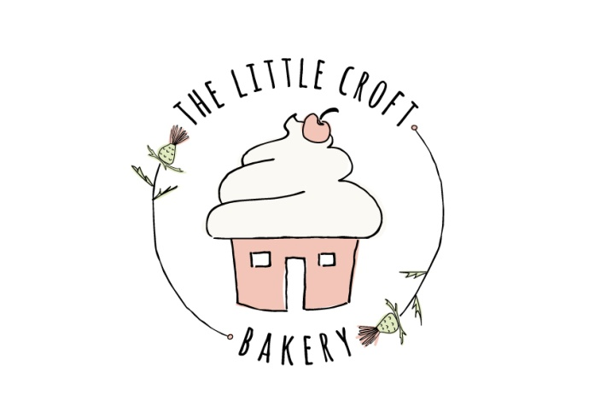

**Eilidh Orrell – 07845503763**

**The Croft, Greenleonachs, Culbokie, IV7 8JD**

Find us on Facebook and Instagram

Cake Collection Agreement

I, __________________, confirm that the cake/ cakes I have received are as expected and I am happy with it/ them.

I accept full responsibility for transporting and storing the cake/ cakes.

I agree that from collection the cakes/ cakes are my full responsibility and no longer that of Eilidh Orrell, Owner of The Little Croft Bakery.

I agree to abide by the transportation guidelines as previously directed.

Signed __________________ Date__________________

Signed Eilidh Orrell, Owner of The Little Croft Bakery_____________________